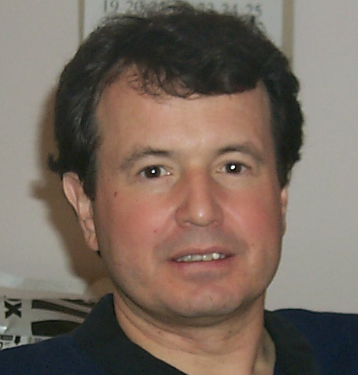
Kyle Fairchild

UK Tel: +44 (0)7916.146.322
kylefairchild@fairchildinnovation.com

EMPLOYMENT HISTORY
2002-Present Principal, Fairchild Innovation Consulting London, United Kingdom
2001-2002 Sloan Fellow, London Business School London, United Kingdom
1998-2001 U.S. Diplomat to Russia and
NASA Deputy Director, Operations - Russia Star City, Moscow Region, Russia
1994-1998 Manager for Enterprise & Marketing Technology Transfer & Commercialization Office NASA-Johnson Space Center
1997 Faculty Member International Space University Rice University Campus
1994-1996 Adjunct Professor of Management University of Houston-Clear Lake
1993-1994 Manager for Technology & Enterprise Technology & Commercial Projects Office, New Initiatives Office NASA- Johnson Space Center
1990-1993 Mission Manager Space Shuttle & Space Station Freedom Payloads Projects Office NASA- Johnson Space Center
1988-1990 Technology Manager Technology & Commercial Projects Office, New Initiatives Office NASA- Johnson Space Center
1984-1988 Aerospace Engineer Advanced Programs Office NASA-Johnson Space Center
1981-1984 Teaching and Research Associate University of Minnesota Department of Aerospace Engineering
1983 AAAS Science Fellow National Public Radio, California Public Radio & Minnesota Public Radio
1974-1977 Russian Translator U.S. Army Security Agency Augsburg, West Germany

RECENT ASSIGNMENTS
Mr. Fairchild is currently building a London-based consultancy for the commercialization of R&D. He has recently completed the Sloan Fellowship Programme at the London Business School. One of three such programs in the world (the others are at MIT and Stanford), the Sloan Fellows Programme is a fulltime executive MBA programme for middle to senior level executives.

Prior to London Business School, Mr. Fairchild was NASA’s Deputy Director, Operations - Russia, and a member of the U.S. Diplomatic Corp in Moscow. Primary responsibilities were for the training and well-being of U.S. astronauts and support staff while they were in Russia. Duties included providing overall directions for housing acquisition and maintenance, development and maintenance of the global telephone and computer networks, implementing US-Russia outer space treaty issues and negotiating training and budget issues with Russian counterparts at the Gagarin Cosmonaut Training Center in Star City (Zvyozdniy Gorodok), Russia.

Previous to this, Mr. Fairchild was responsible for providing overall direction in the assessment of commercial potential of existing and emerging NASA Johnson Space Center (JSC) technologies, packaging and marketing these technologies to meet commercial market needs, and overseeing efforts that result in development of viable commercial products and services.

Specific accomplishments include providing overall direction that resulted in:

- Codifying the "JSC Commercialization Pipeline Model", that outlines all steps in the commercialization process, from initial NASA technology development to commercial production/sales
- Restructuring and implementing the JSC technology marketing and licensing process
- Creating an internal JSC commercialization team that includes all 17 technology divisions, to more effectively develop, inventory, and assess JSC technologies.
- Creating and implementing a commercialization training program for all JSC scientists and engineers
- Defining and implementing the JSC Commercialization Home Page (http//technology.jsc.nasa.gov), for use as a marketing tool and information "wholesaler", providing technology opportunity information to the Regional Technology Transfer Centers, affiliates and others

Mr. Fairchild was also an adjunct professor of management at the University of Houston, Clear Lake. His expertise is the creation and use of customer-focused, network-oriented, self-managing project teams.

In addition, Mr. Fairchild has managed advanced planning projects for future space activities including space transportation, lunar settlements and Mars bases. These projects involve defining and developing future technologies and new relationships among the public, private, academic and international communities.

EDUCATION

2002 Master of Science, Management, Sloan Masters Programme, London Business School, London, UK
1990 International Space University, Toronto, Ontario, Canada
1984 Master of Science, Aerospace Engineering, University of Minnesota
1983 Bachelor of Aerospace Engineering and Mechanics, University of Minnesota
1974 Russian Language Studies, Defense Language Institute, Monterey, California

